Data Challenge 5

## Summarize and Label

For this data challenge, you’re going to plot trends in different regime types over time. The {democracyData} package is an excellent resource for easily accessing all kinds of measures of democracy and regimes over time. The below code will open the packages you need and read in the data:

library(tidyverse)  
library(geomtextpath)  
library(democracyData)  
library(socsci)  
Data <- redownload_pacl(verbose = F)

The redownload_pacl() function reads in data that was used in a [2010 study](https://www.jstor.org/stable/40661005) by Cheibub, Gandhi, and Vreeland on the quality of regime measures. It contains a column called regime that specifies whether a country in the data has one of six different kinds of political regimes. These are given as numerical codes. The below script creates a new pair of columns called regime_name and regime_type based on the values these codes correspond with:

Data %>%  
 mutate(  
 regime_name = frcode(  
 regime == 0 ~ "Parliamentary Democracy",  
 regime == 1 ~ "Mixed Democracy",  
 regime == 2 ~ "Presidential Democracy",  
 regime == 3 ~ "Civilian Autocracy",  
 regime == 4 ~ "Military Dictatorship",  
 regime == 5 ~ "Royal Dictatorship"  
 ),  
 regime_type = ifelse(  
 regime %in% 0:2, "Democracy", "Autocracy"  
 )  
 ) -> Data

Using this data, your challenge is to produce the following figure: 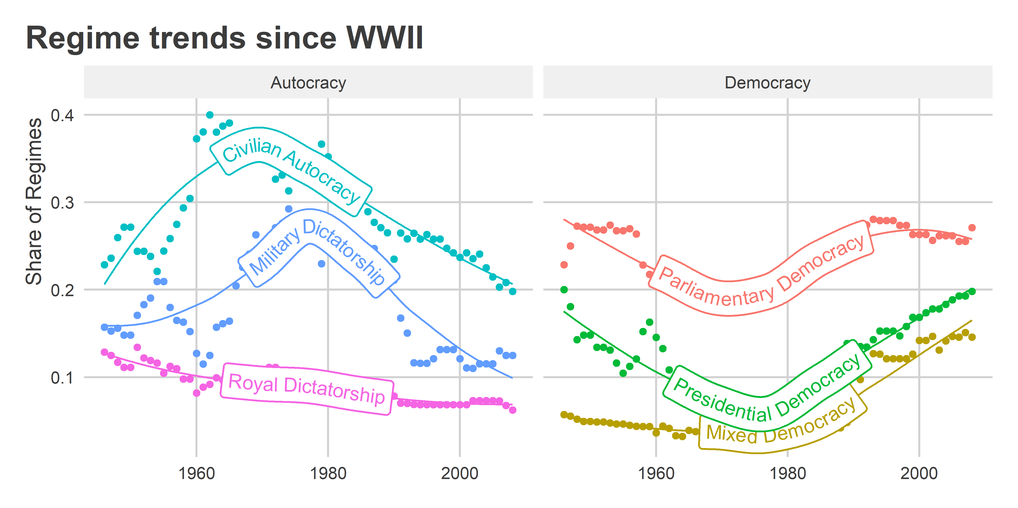

When you’re done. Knit your .Rmd file to either html or word and submit it to Canvas.